Summer Triangle (Winter in the south hemisphere)

Lyra - 天琴座The Lyre

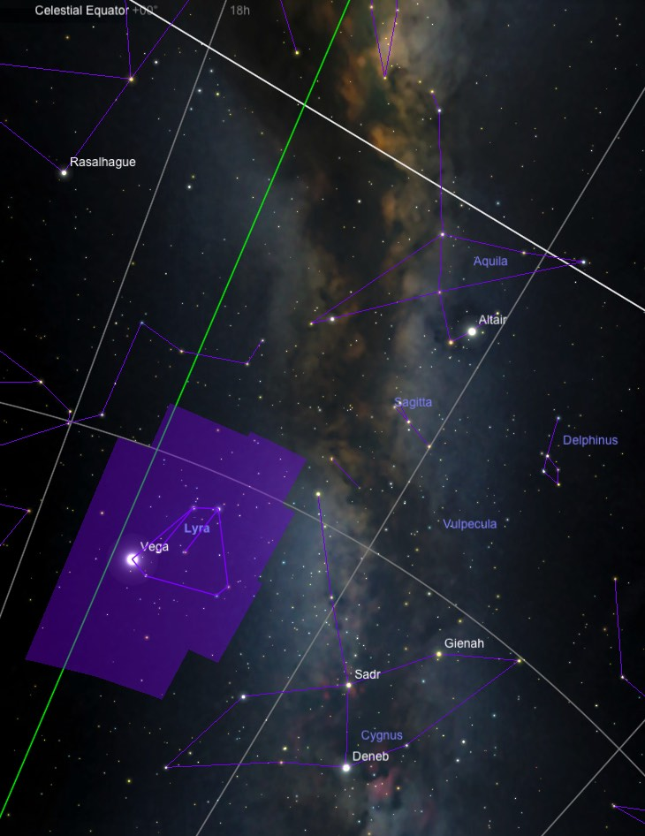

Lyra, the Harp, is a small constellation with a very recognizable shape. It is one of the few constellations that actually resembles the object for which it is named. Lyra is located between Hercules 武仙座 and Cygnus 天鵝座, and is best seen from May through November.

Lyra includes the brilliant star Vega 織女星, one of the brightest stars in the Northern Hemisphere's summer skies. Below Vega is a parallelogram formed by four third magnitude stars.

History and Mythology
The constellation Lyra represents the instrument that was said to be used by Orpheus 奧菲斯. This mythical instrument is said to have been created by the Greek god Hermes赫密士when he came upon a turtle. The god is said to have hollowed out its shell and drawn strings across it, creating the first lyre. Mercury then traded the instrument to Apollo, the sun god, when he was caught stealing Apollo's cattle.

The tale of the Lyre then passes to Orpheus. Apollo became entranced by the songs of the great musician Orpheus and gave him the instrument so that Orpheus could accompany his words. Orpheus is said to have been so grateful for the instrument that he would often seek a high mountain before sunrise, to greet the sun god with his music as he rose in the morning.

Orpheus' most renowned tale is one of the greatest Greek myths. The love story began with Orpheus' marriage to the nymph Eurydice歐律狄刻. One day Satyr薩堤爾, smitten by Eurydice's beauty, chased her through the forest to take her for his own. While fleeing Satyr's pursuit, Eurydice stepped on a nest of vipers and was bitten on the heel. Thus poisoned, the nymph dies. When Orpheus came upon the body of his beloved, he is said to have sung songs so mournful that the muses and gods were brought to tears. Orpheus was so bereft at the loss of his love that he undertook to journey to the underworld and beg for her return to the land of the living. Upon his arrival in the land of the dead, he beseeched Hades 哈得斯 with mournful music. Thus he was the only human ever to warm the hearts of the lords of the underworld. Hades agreed to let Orpheus take Eurydice from the underworld, on condition that during the return trip, he would never turn to look back at the ghost of his wife. The musician readily agreed, and began leading the spirit of his wife through the dark corridors of the underworld with his music. But, as Orpheus and Eurydice neared the end of their long journey back to the land of the living, Orpheus became unnerved by the silence of being followed by a ghost. So, in great worry that she was not really there, he turned around, only to see the spirit of his wife pulled back into the underworld for eternity.

Notable Stars
Alpha Lyrae, the harp star, is commonly known as Vega 織女星. This name comes from an Arabic word "waqi," meaning "vulture." In ancient Egypt and India, the constellation Lyra was represented as a vulture.

Alpha Lyrae is a brilliant, blue-white star 25 light-years away, and it is the 5th brightest star in the sky. It is three times larger than our Sun, and 60 times more luminous. Vega was the first star to be photographed in the 1850's. It was also one of the first stars discovered to have a disk of proto-planetary dust orbiting around it, by the IRAS satellite in 1983. This discovery was inspiration for Vega's role as the home to an extraterrestrial civilization in the famous science fiction movie Contact.

Around 10,000 BCE, Vega was the North Pole Star. It will be the pole star again in AD 14,500.

Physical Properties
Vega is only 25.3 light years away, making it one of the closer stars to Earth. Being nearby, Vega has an angular movement of a degree every 11,000 years. Vega will become the brightest star in the sky in around 210,000 years for about 270,000 years.

Vega has served as the baseline for calibrating the photometric brightness scale.
Although no planets have been directly observed around Vega, the presence of a planetary system cannot yet be precluded.

Vega織女星, Deneb 天津四 in Cygnus 天鵝座, and Altair 牛郎星in Aquila 天鷹座 form the Summer Triangle.

Beta Lyrae is traditionally named Sheliak, which is Arabic for "tortoise" or "harp." Located 880 light-years away, it is the prototype for the class of eclipsing binaries whose components are so close together that they deform each other by their mutual gravitation. Beta Lyrae's apparent magnitude changes from 3.4 to 4.6 over a period of 12.9 days.

Clusters, Nebulae, and Galaxies
The most famous deep sky object in Lyra is M 57, the Ring Nebula環狀星雲. It lies midway between the two lower stars in the parallelogram of Lyra. It is a ninth magnitude planetary nebula which looks like a smoke ring or a pale donut. For a good view, use a 4-inch or larger telescope at a magnification of 200x.

The Ring Nebula is often regarded as the prototype of all planetary nebulae. These objects are the remains of sunlike stars which have blown away their outer envelopes, leaving planet-sized white dwarfs at their centers. The distance to M 57 is not very well known; estimates range from 1400 to 4100 light-years. The current estimate is 2300 light-years, making its physical size about one light-year in diameter.

** Cygnus -天鵝座The Swan

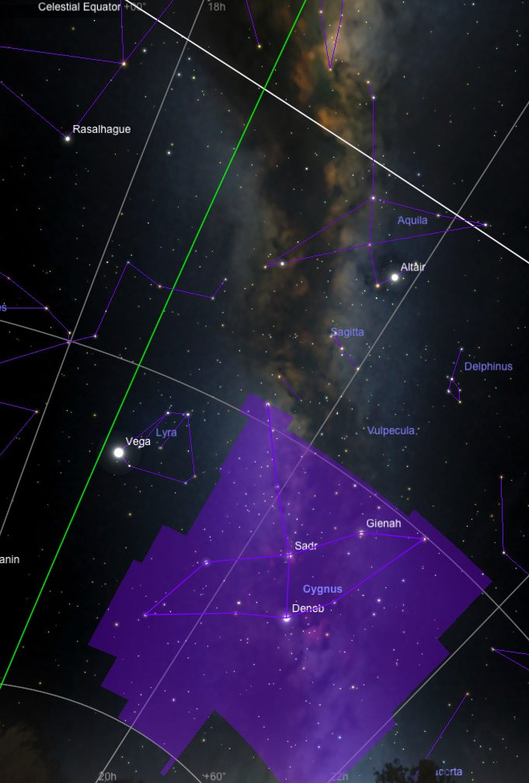

Cygnus is one of the major constellations in the northern hemisphere's summer sky, best seen from June through November. It is also known as the Northern Cross.

History and Mythology
Cygnus has been associated with several myths. One myth represents the bird into which Zeus transformed himself to seduce Leda, the Queen of Sparta. Leda laid the eggs which hatched Helen of Troy and the twins, Castor and Pollux.

Cygnus is sometimes made out to be Orpheus奧菲斯, the Greek tragic hero who was murdered for refusing to honor Dionysus. In death, Orpheus was transformed into a swan and placed in the sky next to the neighboring constellation Lyra.

Another myth tells us that Phaeton法厄同, the young son of Helios赫利俄斯, begged his father to let him drive the chariot of the sun across the sky. After much begging, his father agreed. But Phaeton lost control of the horse, and his chariot burned a wide streak across the sky; this streak became the Milky Way. Zeus was forced to kill Phaeton to stop the destruction, and his body tumbled into a river. Phaeton's best friend Cygnus came to the riverbank every day and cried for his friend. To ease his pain, the gods placed Cygnus in the sky, where he took the form of a swan.

The Chinese also have a myth associated with this constellation. This myth is referred to as the "magpie bridge" 鵲橋.

Notable Stars
Deneb is a blue-white giant star at the tip of the Northern Cross. It is 1400 light-years away, and is the 19th brightest star in the sky - more than 54,00 times the Sun's luminosity - making it one of the most luminous stars in the Milky Way. Due to precession, Deneb was a pole star 18,000 years ago, appearing 7 degrees from the North Celestial Pole. It will be a pole star again around the year 9800 A.D.

Gamma Cygni, or Sadr, is a magnitude 2.2 star lying prominently at the center of Cygnus' cross. It is also a white supergiant lying 1500 light-years away; its name comes from an Arabic phrase that means "the hen's breast." Epsilon Cygni, or Gienah, is a yellow-orange giant 72 light-years away.

Beta Cygni or Albireo is one of the most famous double stars in the sky. It consists of a gold third magnitude star with an indigo fifth magnitude companion, separated by 34 arcseconds. The Albireo system is about 340 light-years away and has an orbital period of at least 75,000 years.

Clusters, Nebulae, and Galaxies
Cygnus contains two planetary nebulae of interest for amateur telescopes. NGC 7027 is a small, relatively bright planetary nebula best viewed with high magnification. NGC 6826 is commonly referred to as the "blinking planetary," although many other nebulae can exhibit such "blinking." Stare at the nebula's central star until its brightness overwhelms the eye, and causes the nebula to fade. When you then glance away, the nebula's disk will reappear. This alteration between direct and averted vision of the nebula's nucleus causes the "blinking" effect.

* Alpha Cygni – Deneb天津四
Deneb is the brightest star in the constellation Cygnus, the Swan, blue-white star of magnitude 1.25.

In Arabic, Deneb's name means "tail" (of the Swan). Due to precession, Deneb was a pole star 18,000 years ago, appearing 7 degrees from the North Celestial Pole. It will be one again around the year 9800 A.D.

Physical Properties
Deneb's exact distance from the Earth is uncertain, the most likely value is 1425 light years. At that distance, Deneb's luminosity is 54,000 times the Sun's, making it among the most luminous stars known. Deneb has a surface temperature of 8,400 K. Based on its temperature and luminosity, Deneb has a diameter 110 times the Sun's. It is one of the largest stars of its kind.

As a white supergiant, its high mass and temperature mean that the star will have a short lifespan. It has already stopped fusing hydrogen in its core. Just 10 to 12 million years old, Deneb will probably become a supernova within a few million years.

** Aquila -天鷹座The Eagle

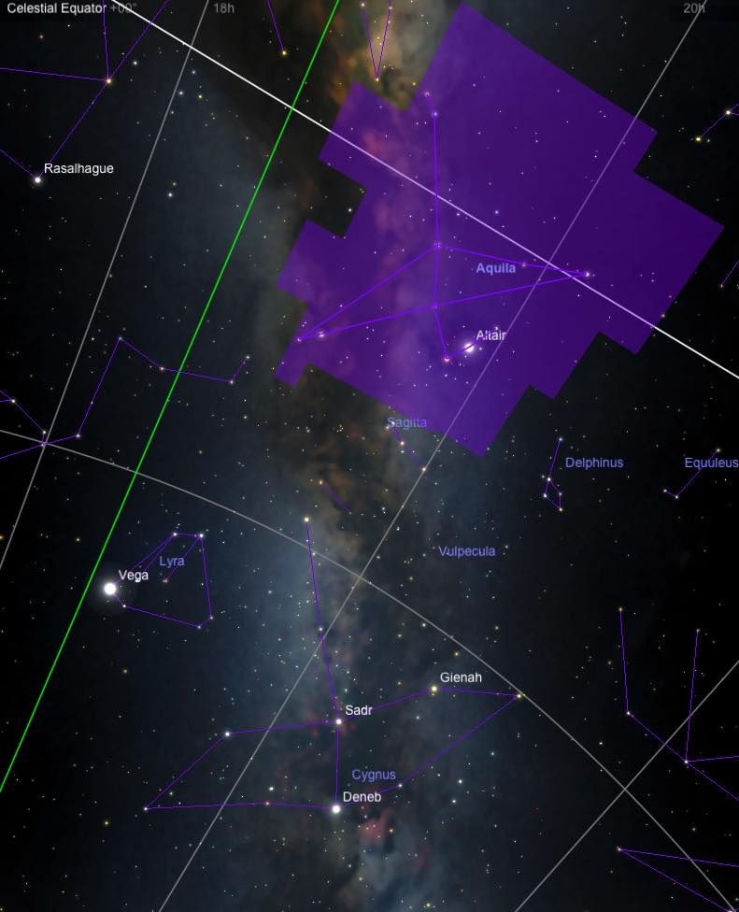

Rising to its zenith in late summer, Aquila forms a triangle in the heavens. Flanked by Aquarius, Hercules, and Ophiuchus, Aquila lies south of Cygnus the Swan and along the summer Milky Way.

History and Mythology
Aquila was one of the 48 constellations catalogued by the 2nd century astronomer, Ptolemy. According to Greek mythology, Aquila is the eagle that held Zeus' thunderbolts. Zeus also sent his eagle to kidnap Ganymede, a shepherd boy, who was taken to become a cup-bearer for the gods at Mount Olympus. The Aquarius constellation is sometimes identified with Ganymede. As a result of its triangular shape, Aquarius has had a long association with birds.

Notable Objects
Since it is located just a few degrees north of the celestial equator and near to the Milky Way, the boundaries of the constellation Aquila contain many clusters and nebulae. Many are hardly visible to the untrained eye. The most prominent and brightest star in Aquila is Altair牛郎星. Derived from arabic, "altair" means "the flying eagle". As a result of being a multiple star system, the yellow-white Altair is ten times more luminous than our sun.

* Alpha Aquilae -牛郎星Altair
Altair is a yellow-white star of magnitude 0.76, the brightest star in Aquila. The Arabic name "Altair" comes from a phrase meaning "the flying eagle."

Properties
At a distance of 16.8 light years, Altair is one of the closest bright stars. Due to its closeness, Altair is moving across the sky against the background of distant stars more quickly than most - a degree in only 5000 years.

Altair is also a very rapid rotator. Its equatorial spin speed is an astonishing 210 km/sec (and may be greater, since its axial tilt is not known), as compared with the Sun's 2 km/sec. With a radius 1.8 times the Sun's, the star has a rotation period of at most only 10 hours, as opposed to nearly a month for our Sun.

Theory predicts that Altair's rapid rotation should cause its surface gravity and effective temperature to be lower at the equator than the poles.

